OSPF version 3 / OSPF for IPv6
With OSPFv3 you wont necessarily start a config with ipv6 router ospf. One major difference between v2 (ipv4) and v3 (ipv6) is that v3 is enabled on a per interface basis, rather than the router config mode used in v2.
The following command starts an OSPFv3 process:
R1(config)#int gig 0/0
R1(config-if)#ipv6 ospf 1 area 0

OSPFv2 (IPv4) vs OSPFv3 (IPv6)
RID determination is done the same way
- Use Highest Loopback address
- If no Loopbacks, then use highest IPv4 address
- OSPFv3 only, if no IPv4 address then you must statically set RID (use IPv4 format still)
Important Similarities
- Neither OSPFv3 nor v2 point-to-point or point-to-multipoint networks elect DRs or BDRs
- Hellos are still sent, LSAs, area 0, stub and total stub area,
- Neighbor Discovery and Adjacencies are the same. NBMP topology still requires the neighbor’s to be statically set.
Important Differences
- OSPFv3 – allows a single link to be part of multiple OSPF instances.
whereas OSPFv2 allows a single to ONLY be part of one OSPF instance.

The OSPFv3 Reserved Addresses
FF02::5 – All OSPF Routers (DR,BDR, DRother)
FF02::6 – All OSPF Designated Routers (DR)

The OSPFv2 Reserved Addresses
224.00.5 – All OSPF Routers (DR,BDR,DRother)
224.00.6 – All OSPF Designated Routers

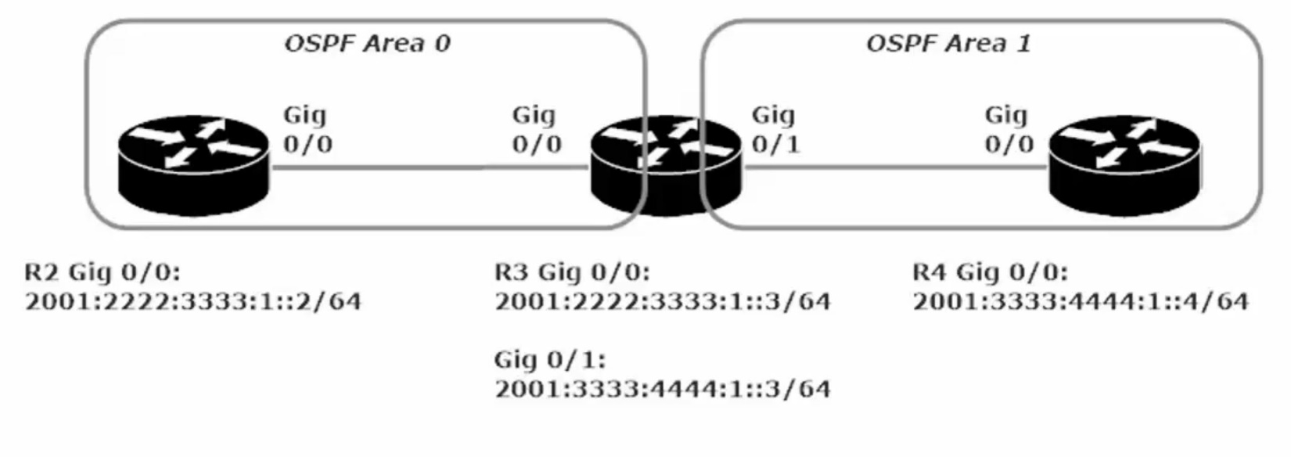
The most important thing to note about this lab is that ipv6 unicast-routing must be enabled, and a router-id needs to be set in the config (#ipv6 ospf 1) if there is no ipv4 address set, Then you simply enable the ipv6 ospf 1 area 0 command of R2 g/0/0 and R3 g0/0 and ipv6 ospf 1 area 1 on R3 g0/1 and R4 g0/0.

Otherwise OSPFv3 is very much the same as OSPFv2

